FIBER OPTICS

QUADERNO DELLO STUDENTE
Read the text and answer the questions

Basic Principles of Fiber Optics
- Introduction
- Basic Principles
- Applied Principles
- Optical Fiber Parameters
- Fiber Manufacturing
- Crossword Puzzle

Introduction
- What is Fiber Optics?
- Fiber Benefits
- Key Points in Fiber History
- Check Your Understanding
- Bibliography
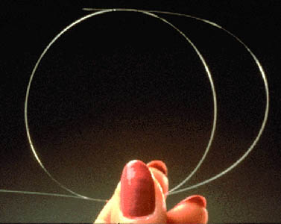
Since its invention in the early 1970s, the use and demand of optical fiber has grown tremendously. The uses of optical fiber today are quite numerous. The most common are telecommunications, medicine, military, automotive, and industrial.
Telecommunications applications are widespread, ranging from global networks to local telephone exchanges to subscribers' homes to desktop computers. These involve the transmission of voice, data, or video over distances of less than a meter to hundreds of kilometers, using one of a few standard fiber designs in one of several cable designs.
Companies such as AT&T, MCI, and U.S. Sprint use optical fiber cable to carry plain old telephone service (POTS) across their nationwide networks. Local telephone service providers use fiber to carry this same service between central office switches at more local levels, and sometimes as far as the neighborhood or individual home.
Optical fiber is also used extensively for transmission of data signals. Private networks are owned by firms such as IBM, Rockwell, Honeywell, banks, universities, Wall Street firms, and more. These firms have a need for secure, reliable systems to transfer computer and monetary information between buildings to the desktop terminal or computer, and around the world. The security inherent in optical fiber systems is a major benefit.
Cable television or community antenna television (CATV) companies also find fiber useful for video services. The high information-carrying capacity, or bandwidth, of fiber makes it the perfect choice for transmitting signals to subscribers.
Finally, one of the fastest growing markets for fiber optics is intelligent transportation systems, smart highways with intelligent traffic lights, automated toll booths, and changeable message signs to give motorists information about delays and emergencies.
These are only a few of the many applications possible with the use of optical fiber. Other telecommunications benefits will be emphasized in more detail throughout this text. website focuses primarily on telecommunications uses of optical fiber. To understand these applications, it is important to define fiber optics.

What is fiber optics
In its simplest terms, fiber optics is a medium for carrying information from one point to another in the form of light. Unlike the copper form of transmission, fiber optics is not electrical in nature.
A basic fiber optic system consists of a transmitting device, which generates the light signal; an optical fiber cable, which carries the light; and a receiver, which accepts the light signal transmitted. The fiber itself is passive and does not contain any active, generative properties.

Fiber benefits
Optical fiber systems have many advantages over metallic-based communication systems. These advantages include:
Long Distance Signal Transmission
The low attenuation and superior signal integrity found in optical systems allow much longer intervals of signal transmission than metallic-based systems. While single-line, voice-grade copper systems longer than a couple of kilometers (1.2 miles) require in-line signal repeaters for satisfactory performance, it is not unusual for optical systems to go over 100 kilometers (km), or about 62 miles, with no active or passive processing. Emerging technologies promise even greater distances in the future.
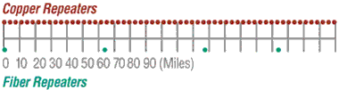
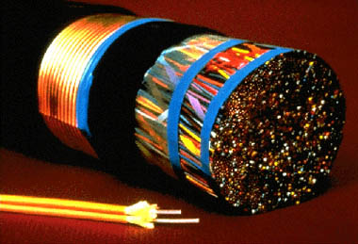
The optical fiber cable in the foreground has the equivalent information-carrying capacity of the copper cable in the background.
Large Bandwidth, Light Weight, and Small Diameter
While today's applications require an ever-increasing amount of bandwidth, it is important to consider the space constraints of many end-users. It is commonplace to install new cabling within existing duct systems. The relatively small diameter and light weight of optical cables makes such installations easy and practical, and saves valuable conduit space in these environments.
Long Lengths
Long, continuous lengths also provide advantages for installers and end-users. Small diameters make it practical to manufacture and install much longer lengths than for metallic cables: twelve-kilometer (12 km) continuous optical cable lengths are common. Corning Cable Systems manufactures continuous single-mode cable lengths up to 12 km, with a 96-inch reel size being the primary limiting factor.
Multimode cable lengths can be 4 km or more, although most standards require a maximum length of 2 km or less. Multimode cable lengths are based on industry demand. (Single-mode and multimode fibers will be covered in detail later in this text.)
Easy Installation and Upgrades
Long lengths make optical cable installation much easier and less expensive. Optical fiber cables can be installed with the same equipment that is used to install copper and coaxial cables, with some modifications due to the small size and limited pull tension and bend radius of optical cables.
Optical cables can typically be installed in duct systems in spans of 6000 meters or more depending on the duct's condition, layout of the duct system, and installation technique. The longer cables can be coiled at an intermediate point and pulled farther into the duct system as necessary.
System designers typically plan optical systems that will meet growth needs for a 15- to 20-year span. Although sometimes difficult to predict, growth can be accommodated by installing spare fibers for future requirements. Installation of spare fibers today is more economical than installing additional cables later.
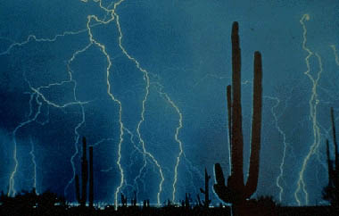
The dielectric nature of optical fiber can eliminate the dangers found in areas of high lightning-strike incidence.
Non-Conductivity
Another advantage of optical fibers is their dielectric nature. Since optical fiber has no metallic components, it can be installed in areas with electromagnetic interference (EMI), including radio frequency interference (RFI). Areas with high EMI include utility lines, power-carrying lines, and railroad tracks. All-dielectric cables are also ideal for areas of high lightning-strike incidence.
Security
Unlike metallic-based systems, the dielectric nature of optical fiber makes it impossible to remotely detect the signal being transmitted within the cable. The only way to do so is by actually accessing the optical fiber itself. Accessing the fiber requires intervention that is easily detectable by security surveillance. These circumstances make fiber extremely attractive to governmental bodies, banks, and others with major security concerns.
Designed for Future Applications Needs
Fiber optics is affordable today, as electronics prices fall and optical cable pricing remains low. In many cases, fiber solutions are less costly than copper.
As bandwidth demands increase rapidly with technological advances, fiber will continue to play a vital role in the long-term success of telecommunications.

Key points in fiber history
Most people remember Paul Revere's "one if by land, and two if by sea" from early American history. He used lanterns to communicate information. Although not sophisticated, this was an early example of optical communication.
In 1870, British physicist John Tyndal gave us another example. Tyndal set up a tank of water with a pipe that ran out one side. He allowed the water to flow from the pipe, and then shone a bright light from inside the tank into the water stream. As the water fell, an arc of light followed the water down. This demonstrated total internal reflection, a principle that will be discussed in more detail later.
In 1880, Alexander Graham Bell invented the photophone. Bell considered this a greater discovery than his previous invention, the telephone. With the photophone, Bell would speak into a microphone, which would cause a mirror to vibrate. The sun's light would strike the mirror, and the vibration of the mirror would transmit the light across an open distance of about 200 meters (656 feet). The receiver's mirror would receive the light and cause a selenium crystal to vibrate, and the noise would come out on the other end. (See Figure 1 below.) Although the photophone was successful in allowing conversation over open space, it had a few drawbacks: it did not work well at night, in the rain, or if someone walked between the signal and the receiver. Eventually, Bell gave up on this idea.
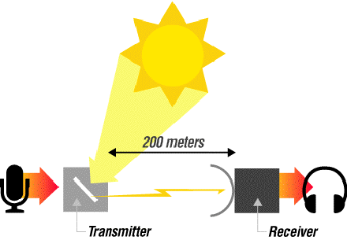
Figure 1
It wasn't until the late 1950s that the laser was invented. This device was a finely-controlled beam of light that could transmit information over long distances. Unfortunately, the same drawbacks experienced by Alexander Graham Bell also plagued the laser. Although it could be used at night, it didn't work during rain, fog, or any time a building was erected between the sender and the receiver.
Dr. Robert Maurer, Peter Schultz, and Donald Keck of Corning Incorporated in Corning, New York, came up with the first low loss optical fiber, with less than 20 dB/km (decibels per kilometer) loss. (Today, single-mode, premium grade fiber is sold with specifications of 0.25 dB/km or better.)
In 1977, Corning joined forces with another technological giant, Siemens Corporation, to form Corning Cable Systems. Corning's extensive work with fiber, coupled with Siemens' cabling technology, helped launch a new era in optical fiber cable and associated products.
Check Your Understanding
1. In what decade did optical fiber communications become commercially viable?
- 1870s
- 1950
- 1970
- 1980s
2. Which of the following is a good example of an optical fiber application for telecommunications?
- Local or long-distance telephone communications
- Medical instruments for orthoscopic surgery
- Missile guidance and target tracking
3. Which of the following is not true about optical fiber transmission systems?
- Can be used for voice or data and video
- Are almost always more expensive than copper
- Easy to install and upgrade
- Are virtually immune to electromagnetic and radio-frequency interference

Once light enters an optical fiber, it travels in a stable state called a mode. There can be from one to hundreds of modes depending on the type of fiber. Each mode carries a portion of the light from the input signal.
Generally speaking, the number of modes in a fiber is a function of the relationship between core diameter, numerical aperture, and wavelength, which will be discussed later in the text.

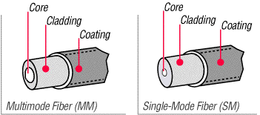Figure 4 Basic principles of operation
- The Information Transmission Sequence
- Cross Section of a Typical Fiber
- Types of Fiber
- Check Your Understanding

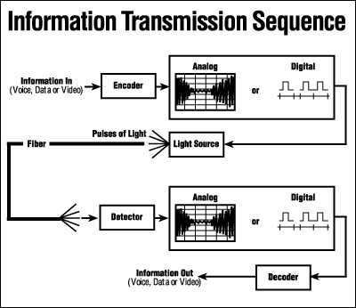Figure 2

The Information Transmission Sequence
As depicted above, information (voice, data, or video) is encoded into electrical signals. At the light source, these electrical signals are converted into light signals.
It is important to note that fiber has the capability to carry either analog or digital signals. Many people believe that fiber can transmit only digital signals due to the on/off binary characteristic of the light source. The intensity of the light and the frequency at which the intensity changes can be used for AM and FM analog transmission.
Once the signals are converted to light, they travel down the fiber until they reach a detector, which changes the light signals back into electrical signals. This area from light source to detector constitutes the passive transmission subsystem; i.e. that part of the system manufactured and sold by Corning Cable Systems.
Finally, the electrical signals are decoded into information in the form of voice, data, or video.

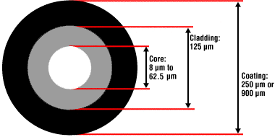Figure 3

Optical fiber for telecommunications consists of three components: core, cladding & coating.
The core is the central region of an optical fiber through which light is transmitted. In general, the telecommunications industry uses sizes from 8.3 micrometers (µm) to 62.5 micrometers. The standard telecommunications core sizes in use today are 8.3 µm (single-mode), 50 µm (multimode), and 62.5 µm (multimode). (Single-mode and multimode will be discussed shortly.) The diameter of the cladding surrounding each of these cores is 125 µm. Core sizes of 85 µm and 100 µm have been used in early applications, but are not typically used today.
To put these sizes into perspective, compare them to a human hair, which is approximately 70 µm or 0.003 inch.
The core and cladding are manufactured together as a single piece of silica glass with slightly different compositions, and cannot be separated from one another. The glass does not have a hole in the core, but is completely solid throughout.
The third section of an optical fiber is the outer protective coating. This coating is typically an ultraviolet (UV) light-cured acrylate applied during the manufacturing process to provide physical and environmental protection for the fiber. During the installation process, this coating is stripped away from the cladding to allow proper termination to an optical transmission system.
The coating size can vary, but the standard sizes are 250 µm or 900 µm. The 250 µm coating takes less space in larger outdoor cables. The 900 µm coating is larger and more suitable for smaller indoor cables.

Types of fiber

Every telecommunications fiber falls into one of two categories: single-mode or multimode.
It is impossible to distinguish between single-mode and multimode fiber with the naked eye. There is no difference in outward appearance, only in core size. Both fiber types act as a transmission medium for light, but they operate in different ways, have different characteristics, and serve different applications.
Single-mode (SM) fiber allows for only one pathway, or mode, of light to travel within the fiber. The core size is typically 8.3 µm. Single-mode fibers are used in applications where low signal loss and high data rates are required, such as on long spans where repeater/amplifier spacing needs to be maximized.
Multimode (MM) fiber allows more than one mode of light. Common MM core sizes are 50 µm and 62.5 µm. Multimode fiber is better suited for shorter distance applications. Where costly electronics are heavily concentrated, the primary cost of the system does not lie with the cable. In such a case, MM fiber is more economical because it can be used with inexpensive connectors and LED transmitters, making the total system cost lower. This makes MM fiber the ideal choice for short distance, lower bandwidth applications.

Check Your Understanding
- What purpose does the core of an optical fiber serve?
  - It protects the fiber from the environment
  - It carries light through the fiber
  - It separates the cladding and the coating
- Which of the following is NOT true of single-mode fiber?
- It carries more information than multimode fiber
- Its core is smaller than multimode fiber
- It is hollow in the center
- At installation, which of the following is NOT true about optical fiber?
- The cladding and coating are stripped away
- The fiber has the ability to carry either analog or digital signals
- Light signals must enter the fiber within the acceptance cone to propagate
Applied principles of operation
- Index of Refraction (IOR)
- Total Internal Reflection
- Acceptance Cone
- Check Your Understanding

Index of Refraction (IOR)
The index of refraction (IOR) is a way of measuring the speed of light in a material. Light travels fastest in a vacuum, such as outer space. The actual speed of light in a vacuum is 300,000 kilometers per second, or 186,000 miles per second.
Index of Refraction is calculated by dividing the speed of light in a vacuum by the speed of light in some other medium.

The Index of Refraction of a vacuum by definition has a value of 1.
For the sake of simplicity, typical values are provided here in Figure 5. Notice that the typical value for the cladding of an optical fiber is 1.46. The core value is 1.48. The larger the index of refraction, the more slowly light travels in that medium.
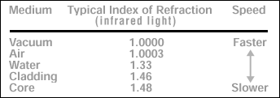Figure 5

Total Internal Reflection
When a light ray traveling in one material hits a different material and reflects back into the original material without any loss of light, total internal reflection occurs.
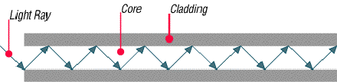
Since the core and cladding are constructed from different compositions of glass, theoretically, light entering the core is confined to the boundaries of the core because it reflects back whenever it hits the cladding. For total internal reflection to occur, the index of refraction of the core must be higher than that of the cladding.

Acceptance Cone
As mentioned earlier, electrical signals are converted to light signals before they enter an optical fiber. To ensure that the signals reflect and travel correctly through the core, the light must enter the core through an imaginary acceptance cone. (See Figure 7 below.) The size of this acceptance cone is a function of the refractive index difference between the core and the cladding.
In simpler terms, there is a maximum angle from the fiber axis at which light may enter the fiber so that it will propagate, or travel, in the core of the fiber. The sine of this maximum angle is the numerical aperture (NA) of the fiber. Fiber with a larger NA requires less precision to splice and work with than fiber with a smaller NA. Single-mode fiber has a small NA.
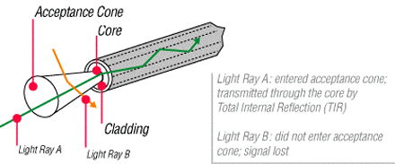
Check Your Understanding
1. Which of the following is true of the index of refraction?
- It is a way of measuring the speed of light in a material
- It is calculated by dividing the speed of light in some medium by the speed of light in a vacuum
- When calculated it shows that the fastest light speed occurs in air

2. Total internal reflection is?
- Reflection that occurs when a light ray traveling in one material hits another material and reflects back into the original material without any loss of light
- Complete meditation without interruption
- Reflection that occurs when the refractive index of the core is lower than the cladding
Optical fiber parameter
- Wavelength
- Window
- Frequency
- Attenuation
- Intrinsic Attenuation
- Extrinsic Attenuation
- Dispersion
- Bandwidth
- Check Your Understanding
As with any type of transmission system, there are certain parameters that affect the system's operation.

Wavelength
Light that can be seen by the unaided human eye is said to be in the visible spectrum. In the visible spectrum, wavelength can be described as the color of light.
To put this into perspective, take a look at Figure 8. Notice that the colors of the rainbow - red, orange, yellow, green, blue, (indigo, not shown), and violet fall within the visible spectrum.
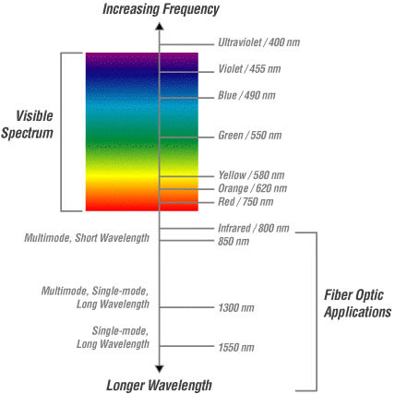Figure 8
Optical fiber transmission uses wavelengths which are above the visible light spectrum, and thus undetectable to the unaided eye. Typical optical transmission wavelengths are 850 nanometers (nm), 1310 nm, and 1550 nm.
Both lasers and LEDs (light-emitting diodes) are used to transmit light through optical fiber. Lasers are usually used for 1310 or 1550 nanometer, single-mode applications. * LEDs are used for 850 or 1300 nanometer multimode applications.
*Safety note: Never look into the end of a fiber which may have a laser coupled to it. Laser light is invisible and can damage the eyes. Viewing it directly does not cause pain. The iris of the eye will not close involuntarily as when viewing a bright light; consequently, serious damage to the retina of the eye is possible. Should accidental exposure to laser light be suspected, an eye examination should be arranged immediately.

Window
There are ranges of wavelengths at which the fiber operates best. Each range is known as an operating window. Each window is centered around the typical operational wavelength.
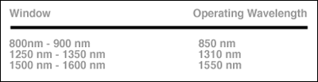Figure 9
These wavelengths were chosen because they best match the transmission properties of available light sources with the transmission qualities of optical fiber.

Frequency
The frequency of a system is the speed of modulation of the digital or analog output of the light source; in other words, the number of pulses per second emitted from the light source. Frequency is measured in units of hertz (Hz), where 1 hertz is equal to 1 pulse or cycle per second (Figure 10). A more practical measurement for optical communications is megahertz (MHz) or millions of pulses per second.
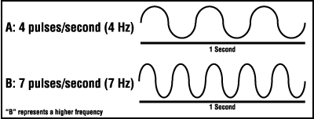Figure 10

Attenuation
Attenuation is the loss of optical power as light travels down a fiber. It is measured in decibels (dB/km). Over a set distance, a fiber with a lower attenuation will allow more power to reach its receiver than a fiber with higher attenuation.
While low-loss optical systems are always desirable, it is possible to lose a large portion of the initial signal power without significant problems. A loss of 50% of initial power is equal to a 3.0 dB loss. Any time fibers are joined together there will be some loss. Losses for fusion splicing and for mechanical splicing are typically 0.2 dB or less.
Attenuation can be caused by several factors, but is generally placed in one of two categories: intrinsic or extrinsic.

Intrinsic Attenuation
Intrinsic attenuation occurs due to something inside or inherent to the fiber. It is caused by impurities in the glass during the manufacturing process. As precise as manufacturing is, there is no way to eliminate all impurities, though technological advances have caused attenuation to decrease dramatically since the first optical fiber in 1970.
When a light signal hits an impurity in the fiber, one of two things will occur: it will scatter or it will be absorbed.
Scattering
Rayleigh scattering accounts for the majority (about 96%) of attenuation in optical fiber. Light travels in the core and interacts with the atoms in the glass. The light waves elastically collide with the atoms, and light is scattered as a result.
Rayleigh scattering is the result of these elastic collisions between the light wave and the atoms in the fiber. If the scattered light maintains an angle that supports forward travel within the core, no attenuation occurs. If the light is scattered at an angle that does not support continued forward travel, the light is diverted out of the core and attenuation occurs.
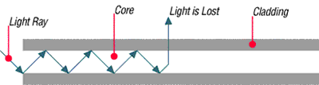
Figure 11
Some scattered light is reflected back toward the light source (input end). This is a property that is used in an Optical Time Domain Reflectometer (OTDR) to test fibers. This same principle applies to analyzing loss associated with localized events in the fiber, such as splices.
Absorption
The second type of intrinsic attenuation in fiber is absorption. Absorption accounts for 3-5% of fiber attenuation. This phenomenon causes a light signal to be absorbed by natural impurities in the glass, and converted to vibrational energy or some other form of energy. (Figure 12)
Unlike scattering, absorption can be limited by controlling the amount of impurities during the manufacturing process.
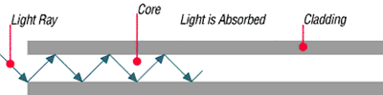Figure 12

Extrinsic Attenuation
The second category of attenuation is extrinsic attenuation. Extrinsic attenuation can be caused by two external mechanisms: macrobending or microbending. Both cause a reduction of optical power.
Macrobending
If a bend is imposed on an optical fiber, strain is placed on the fiber along the region that is bent. The bending strain will affect the refractive index and the critical angle of the light ray in that specific area. As a result, light traveling in the core can refract out, and loss occurs. (Figure 13)
A macrobend is a large-scale bend that is visible; for example, a fiber wrapped around a person's finger. This loss is generally reversible once bends are corrected.
To prevent macrobends, all optical fiber (and optical fiber cable) has a minimum bend radius specification that should not be exceeded. This is a restriction on how much bend a fiber can withstand before experiencing problems in optical performance or mechanical reliability. The rule of thumb for minimum bend radius is 1 1/2" for bare, single-mode fiber; 10 times the cable's outside diameter (O.D.) for non-armored cable; and 15 times the cable's O.D. for armored cable.
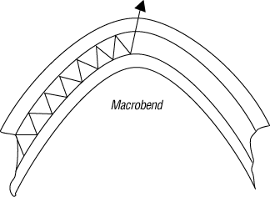
Figure 13
Microbending
The second extrinsic cause of attenuation is a microbend. This is a small-scale distortion, generally indicative of pressure on the fiber. (See Figure 14 below.) Microbending may be related to temperature, tensile stress, or crushing force. Like macrobending, microbending will cause a reduction of optical power in the glass.
Microbending is very localized, and the bend may not be clearly visible upon inspection. With bare fiber, microbending may be reversible; in the cabling process, it may not.
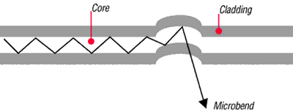Figure 14

Dispersion
Dispersion is the "spreading" of a light pulse as it travels down a fiber. (See Figure 15.) As the pulses spread, or broaden, they tend to overlap, and are no longer distinguishable by the receiver as 0s and 1s. Light pulses launched close together (high data rates) that spread too much (high dispersion) result in errors and loss of information.
Chromatic dispersion occurs as a result of the range of wavelengths in the light source. Light from lasers and LEDs consists of a range of wavelengths. Each of these wavelengths travels at a slightly different speed. Over distance, the varying wavelength speeds cause the light pulse to spread in time. This is of most importance in single-mode applications.
Modal dispersion is significant in multimode applications, where the various modes of light traveling down the fiber arrive at the receiver at different times, causing a spreading effect.
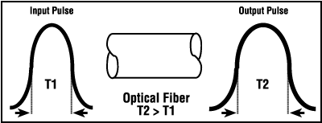Figure 15

Pulse width is measured at full width-half maximum; in other words, the full width of the pulse, at half the maximum pulse height. Dispersion limits how fast, or how much, information can be sent over an optical fiber.
There are other effects of dispersion, but further discussion is beyond the scope of this text. For more in-depth reading, please consult the bibliography at the end of this publication.

Bandwidth
In simplest terms, bandwidth is the amount of information a fiber can carry so that every pulse is distinguishable by the receiver at the end. (Figure 16)
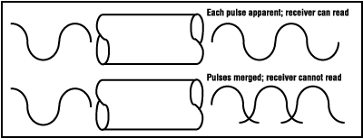Figure 16

As discussed in the previous section, dispersion causes light pulses to spread. The spreading of these light pulses causes them to merge together. At a certain distance and frequency, the pulses become unreadable by the receiver. The multiple pathways of a multimode fiber cause this overlap to be much greater than for single-mode fiber. These different paths have different lengths, which cause each mode of light to arrive at a different time.
System bandwidth is measured in megahertz (MHz) at one km. In general, when a system's bandwidth is 200 MHz·km, it means that 200 million pulses of light per second will travel down 1 km (1000 meters) of fiber, and each pulse will be distinguishable by the receiver.
Check Your Understanding
1. In optical fiber systems, what are the typical wavelengths of operation?
- 400 nm 455 nm 490 nm
- 620 nm 750 nm 800 nm
- 850 nm 1310 nm 1550 nm
2. What is an optical window?
- A glass object on the side of a building
- A range of wavelengths at which fiber best operates
- The moment in time when fiber became a commercially-viable enterprise
- Which of the following is not true of attenuation?
- It is the loss of optical power as light travels down a fibeIt may be induced by scattering
- absorbing macrobending and microbending
- It is measured in nanometers
4. What is bandwidth?
- A measure of the information-carrying capacity of an optical fiber
- The side-to-side measurement of a wedding ring
- A term used to express the total loss of an optical system
Fiber manufacturing
- Laydown
- Consolidation
- Draw
- Check Your Understanding
There are several ways to manufacture optical fiber, but this text will concentrate on the method developed, patented, and used by the former Corning Glass Works, now Corning Incorporated.
This method, called Outside Vapor Deposition, or OVD, has three steps or phases: laydown, consolidation, and draw.

Laydown
In the laydown step, a soot preform is made from ultrapure vapors of silicon tetrachloride and germanium tetrachloride. The vapors travel through a traversing burner and react in the flame to form soot particles of silica and germania.
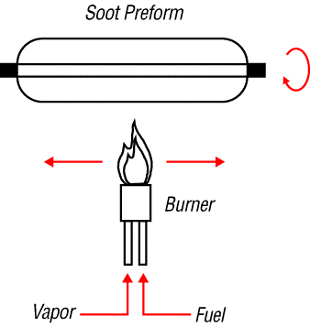
Figure 17
The OVD process is distinguished by the method of depositing the soot. These particles are deposited on the surface of a rotating target rod. The core material is deposited first, followed by the pure silica cladding. Since both core and cladding raw materials are vapor-deposited, the entire preform is extremely pure.

Consolidation
When deposition is complete, the target rod is removed from the center of the porous preform and the preform is placed into a consolidation furnace. During the consolidation process, the water vapor is removed from the preform. This high-temperature consolidation step sinters the preform into a solid, dense, transparent glass blank. The hole left by the target rod is fused solid by the extremely high temperature of the draw furnace.

Draw
The finished glass preform is placed in a draw tower and drawn into a continuous strand of glass fiber. First the blank is lowered into the top of the draw furnace.
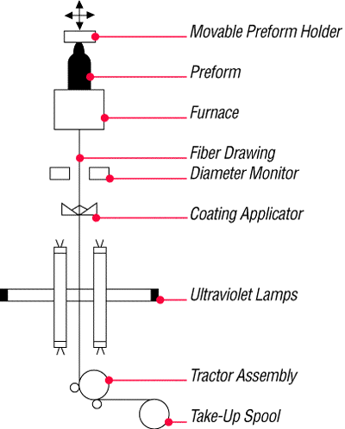
Figure 18
The tip of the blank is heated until a piece of molten glass, called a gob, begins to fall from the blank like hot taffy. It pulls a thin strand of glass, the beginning of an optical fiber.
The fiber goes through a precise on-line diameter monitor to ensure specified outside diameter. Next, coatings are applied and cured, using ultraviolet lamps.
At the bottom of the draw, the fiber is wound on spools. Each fiber is assigned a unique identification number that encodes all relevant manufacturing data, including raw materials and manufacturing equipment.
Note: Extensive text and graphics in this Fiber Manufacturing section are used with permission of Corning Communications.

Check Your Understanding
Would you like to see how much you've learned?
- What are the three steps of fiber manufacture using the Outside Vapor Deposition (OVD) method?
- Burner vapor fuel
- Laydown consolidation draw
- Gas glass spool
- Which of the following is NOT true about the laydown stage of OVD fiber manufacture?
- A rotating target rod collects soot deposited from the burner
- The soot forms a perform
- The preform is highly impure until it reaches the consolidation phase
- Which of the following is NOT true about the consolidation stage of fiber manufacture?
- The removal of the target rod causes the core of the fiber to be hollow
- Water vapor is removed from the perform
- The white preform becomes a solid dense transparent glass blank
4. Which of the following is NOT true about the draw stage of fiber manufacture
- The glass preform is drawn into a continuous piece of glass fiber
- Fiber diameters are measured on-line
- Coatings are applied and cured using infrared lamps
Crossword puzzle1
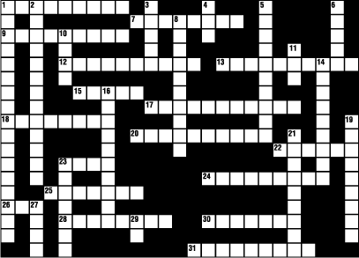
Across
1: a large cable bend that can be seen with the unaided eye
7: material surrounding the core of a fiber
9: measurement typically used to express the wavelength of light; one billionth of a meter
12: spreading of a light pulse as it travels down a fiber
13: characteristic of light that is emitted from the light source and is measured in nm; can be described as the color of light
15: electronic device that converts input power into a beam of coherent visible or infrared light
17: loss of signal power in an optical fiber
18: LASER stands for light amplification by stimulated _______________ of radiation
20: loss of light energy in an optical fiber resulting from impurities in the glass
22: one millionth of a meter; also known as a micrometer
23: central region of an optical fiber through which light is transmitted
24: equivalent to one million hertz
25: first of three steps in the manufacture of fiber
26: method of fiber manufacture developed by Corning and licensed to Lucent Technologies (abbrev.)
28: total ______________ reflection
30: the pulling force necessary to break a material is known as ____________strength
31: more than one mode
Down
1: amount of bend a fiber can withstand before experiencing problems in performance (3 words)
2: measure of optical fiber core deviation from its ideal center position
3: material of which optical fiber is made
4: reflection that occurs when a light ray traveling in one material hits a different material and reflects back into the original material without any loss of light (abbrev.)
5: abrupt change in the direction of a light beam so that it returns to the medium from which it originated
6: optical fiber's form of transmission
8: Corning's method of fiber manufacture: outside vapor _________________
10: pathway in which light travels down a fiber
11: semiconductor device that emits noncoherent optical radiation when biased in the forward direction; a.k.a. light-emitting diode
14: equivalent to one billion hertz
16: having only one path for light transmission
19: information-carrying capacity
21: small microscopic bend usually not visible to the unaided eye
23: material put on a fiber during the draw process to protect it from the environment
27: third step in the fiber manufacturing process
Crossword puzzle2
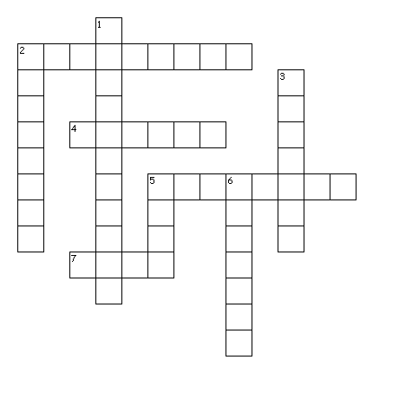
Across
2. An optical waveguide in which light travels in multiple modes;
4. A format that uses continuous physical variables such as voltage amplitude or frequency variations to transmit information.
5. The material surrounding the core of an optical waveguide that must have a lower index of refraction to keep the light in the core.
7. A term used to describe the way in which light travels through a fiber

Down
1. The decrease in magnitude of power of a signal in transmission between points; a term used for expressing the total loss of an optical system, normally measured in decibels (dB) at a specific wavelength.
2. An optical waveguide (or fiber) in which the signal travels in one mode.
3. A material applied to a fiber during the draw process to protect it from the environment and handling.
5. The central region of an optical fiber through which light is transmitted.
6. A data format that uses two physical levels to transmit information corresponding to 0s and 1s. A discrete or discontinuous signal.

Crossword puzzle3
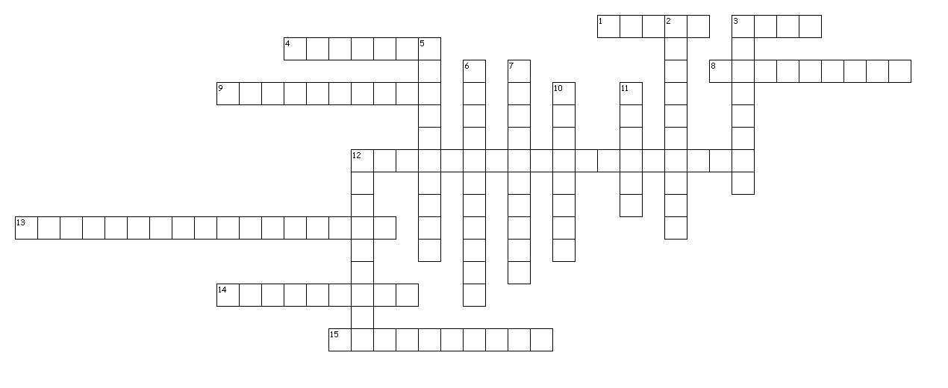
Across
1. kind of dispersion significant in multimode applications
3. The area in which the light rays direction allows them to travel correctly without any loss of power
4. ranges of wavelenght at wich the fibers operate best
8. amount of information a fiber can carry
9. the spreading of a light pulse as it travel down a fiber
12. When a light ray travels in one fibre without any loss of power
13. the sine of the maxixmum angle at wich light may enter to propagate
14. attenuation caused by the bending of the fiber
15. it accounts for the majority of attenuation in optical fiber

Down
2. intrinsic attenuation due to natural impurities in the glass
3. In which part of the FO is the speed faster?
5. a fiber with a small NA
6. loss of optical power as light travels down on a fiber
7. can be defined as the color of light in the visible spectrum
10. a function of the refractive index difference between the core and the cladding
11. the kind of relationship between IOR and speed of light in a vacuum
12. attenuation that is due to something inside the fiber
Fill in the blanks with appropriate terms
Frequency
The number of .........per second; measured in units of Hertz (Hz) where 1 hertz equals 1 pulse/cycle per second.
Attenuation
The decrease in ......... of power of a signal in transmission between points; A term used for expressing the total .........of an optical system, normally measured in decibels (dB) at a specific ..........
Attenuation Coefficient
The rate of optical power loss with respect to distance along the fiber, usually measured in decibels per kilometer (dB/km) at a specific wavelength; the ......... the number, the better the fiber's attenuation.
Bandwidth
Measure of the information-......... .........of an optical fiber.
Dispersion
The cause of .........limitations in a fiber. Dispersion causes a ......... of input pulses along the length of the fiber. Three major types are (1) modal dispersion caused by differential optical ......... ......... in a multimode fiber; (2) chromatic dispersion caused by a differential ......... of various wavelengths of light in a waveguide material; and (3) waveguide dispersion caused by light travelling in both the core and cladding materials in .........-mode fibers.
Extrinsic
; ......... the fiber.
Fusion Splicing
A permanent .........produced by the application of localized heat sufficient to .........or melt the ends of the optical fiber, forming a continuous single fiber.
Index of Refraction (IOR)
The ......... of light velocity in a vacuum to its velocity in a given transmission medium
Intrinsic
......... the fiber.
Microbend
A ......... bend which may be caused by the cabling process;
Numerical Aperture (NA)
The number that expresses the ......... gathering ability of a fiber; related to acceptance angle or the ......... in index of refraction between the core and the cladding.
Scattering
The loss of signal power (light) from the fiber ......... caused by impurities or changes in the ......... ......... ......... of the fiber.

Splicing
The ......... joining of bare fiber ends to another fiber.
Visible spectrum
The portion of the ......... spectrum that can be seen by the unaided human eye.
Wavelength
The distance between two ......... points of an electromagnetic waveform, usually measured in .........
FIBER OPTICS GLOSSARY
Attenuation
The decrease in magnitude of power of a signal in transmission between points; a term used for expressing the total loss of an optical system, normally measured in decibels (dB) at a specific wavelength.
Analog
A format that uses continuous physical variables such as voltage amplitude or frequency variations to transmit information.
Digital
A data format that uses two physical levels to transmit information corresponding to 0s and 1s. A discrete or discontinuous signal.
Core
The central region of an optical fiber through which light is transmitted.
Cladding
The material surrounding the core of an optical waveguide. The cladding must have a lower index of refraction to keep the light in the core.
Coating
A material applied to a fiber during the draw process to protect it from the environment and handling.
Mode
A term used to describe an independent light path through a fiber, as in multimode or single-mode.
Single-Mode Fiber (SM)
An optical waveguide (or fiber) in which the signal travels in one mode. The fiber has a small core diameter, typically 8.3 µm.
Multimode Fiber (MM)
An optical waveguide in which light travels in multiple modes; typical core/cladding sizes (measured in micrometers) are 62.5/125.
Frequency
The number of pulses or cycles per second; measured in units of Hertz (Hz) where 1 hertz equals 1 pulse/cycle per second.
Attenuation Coefficient
The rate of optical power loss with respect to distance along the fiber, usually measured in decibels per kilometer (dB/km) at a specific wavelength; the lower the number, the better the fiber's attenuation. Typical multimode wavelengths are 850 and 1300 nanometers (nm); single-mode wavelengths are 1310 and 1550 nm. Note: When specifBandwidth
Measure of the information-carrying capacity of an optical fiber. Note: This term is often used to specify the normalized modal bandwidth (MHz·km) of a multimode fiber. See Dispersion for single-mode fibers.
Dispersion
The cause of bandwidth limitations in a fiber. Dispersion causes a broadening of input pulses along the length of the fiber. Three major types are (1) modal dispersion caused by differential optical path lengths in a multimode fiber; (2) chromatic dispersion caused by a differential delay of various wavelengths of light in a waveguide material; and (3) waveguide dispersion caused by light traveling in both the core and cladding materials in single-mode fibers.
Extrinsic
External; outside the fiber.
Fusion Splicing
A permanent joint produced by the application of localized heat sufficient to fuse or melt the ends of the optical fiber, forming a continuous single fiber.
Index of Refraction (IOR)
The ratio of light velocity in a vacuum to its velocity in a given transmission medium
Intrinsic
Inherent; within; inside the fiber.
Microbend
A small, microscopic bend which may be caused by the cabling process; mechanical stress due to water in the cable during repeated freeze and thaw cycles, packaging, or installation
Numerical Aperture (NA)
The number that expresses the light gathering ability of a fiber; related to acceptance angle or the difference in index of refraction between the core and the cladding.
Scattering
The loss of signal power (light) from the fiber core caused by impurities or changes in the index of refraction of the fiber.

Splicing
The permanent joining of bare fiber ends to another fiber. See Fusion Splice and Mechanical Splicing.
Visible spectrum
The portion of the electromagnetic spectrum that can be seen by the unaided human eye.
Wavelength
The distance between two successive points of an electromagnetic waveform, usually measured in nanometers (nm).

QUADERNO DELL’INSEGNANTE

Check you understanding key
Introduction
1. C: 1970s
2. A: local or long-distance telephone communications
3. B: are almost always more expensive than copper
Basic Principles
1. B: it carries light through the fiber
2. C: it is hollow in the center
3. A: the cladding and coating are stripped away
Applied Principles
1. A: it is a way of measuring the speed of light in a material
2. A: reflection that occurs when a light ray traveling in one material hits another material and reflects back into the original material without any loss of light
Optical Fiber Parameters
1. C: 850 nm, 1300 nm, 1550 nm
2. B: an operational range of wavelengths at which fiber best operates
3. C: it is measured in nanometers
4. A: a measure of the information-carrying capacity of an optical fiber
Fiber Manufacturing
1. B: laydown, consolidation, draw
2. C: the preform is highly impure until it reaches the consolidation phase
3. A: the removal of the target rod causes the core of the fiber to be hollow
4. C: coatings are applied and cured, using infrared lamps
Crossword Puzzle1
Across
1: Macrobend
7: Cladding
9: Nanometer
12: Dispersion
13: Wavelength
15: LASER
17: Attenuation
18: Emission
20: Absorption
22: Micron
23: Core
24: Megahertz
25: Laydown
26: IVD
28: Internal
30: Tensile
31: Multimode
Down
1: Minimum bend radius
2: Concentricity
3: Glass
4: TIR
5: Reflection
6: Light
8: Deposition
10: Mode
11: LED
14: Gigahertz
16: Singlemode
19: Bandwidth
21: Microbend
23: Coating
27: Draw
29: NY
Crossword Puzzle2
digital A data format that uses two physical levels to transmit information corresponding to 0s and 1s. A discrete or discontinuous signal.
coating A material applied to a fiber during the draw process to protect it from the environment and handling.
core The central region of an optical fiber through which light is transmitted.
attenuation The decrease in magnitude of power of a signal in transmission between points; a term used for expressing the total loss of an optical system, normally measured in decibels (dB) at a specific wavelength.
mode A term used to describe the way in which light travels through a fiber
multimode An optical waveguide in which light travels in multiple modes;
cladding The material surrounding the core of an optical waveguide that must have a lower index of refraction to keep the light in the core.
monomode An optical waveguide (or fiber) in which the signal travels in one mode.
analog A format that uses continuous physical variables such as voltage amplitude or frequency variations to transmit information.

Crossword Puzzle3
cladding In which part of the FO is the speed faster?
core The area in which the light rays direction allows them to travel correctly without any loss of power
internalreflection When a light ray travels in one fibre without any loss of power
direct the kind of relationship between IOR and speed of light in a vacuum
conesize a function of the refractive index difference between the core and the cladding
numericalaperture the sine of the maximum angle at which light may enter to propagate
singlemode a fiber with a small NA
wavelenght can be defined as the color of light in the visible spectrum
windows ranges of wavelength at which the fibers operate best
attenuation loss of optical power as light travels down on a fiber
intrinsic attenuation that is due to something inside the fiber
scattering it accounts for the majority of attenuation in optical fiber
absorption intrinsic attenuation due to natural impurities in the glass
extrinsic attenuation caused by the bending of the fiber
dispersion the spreading of a light pulse as it travel down a fiber
modal kind of dispersion significant in multimode applications
bandwidth amount of information a fiber can carry

